Surname: First name: University card number:

Safety induction completed (date): / /

LINE MANAGER TO COMPLETE & SIGN | Role requires  (‘Yes’ or ‘No’) | Medical fitness to work confirmed | Mandatory training completion confirmed
Driving of University vehicles | NO
Working in noisy environments | NO
Manual handling. | NO
Working with lasers | NO
Classified radiation work | NO
Clinical work | NO
Animal work | NO
Regular use of a computer | YES | YES | YES
Food handling. | NO
Working at height. | NO
Regular out of hours work. | NO
Chemicals including CMRs | NO
Biologicals including GMOs | NO
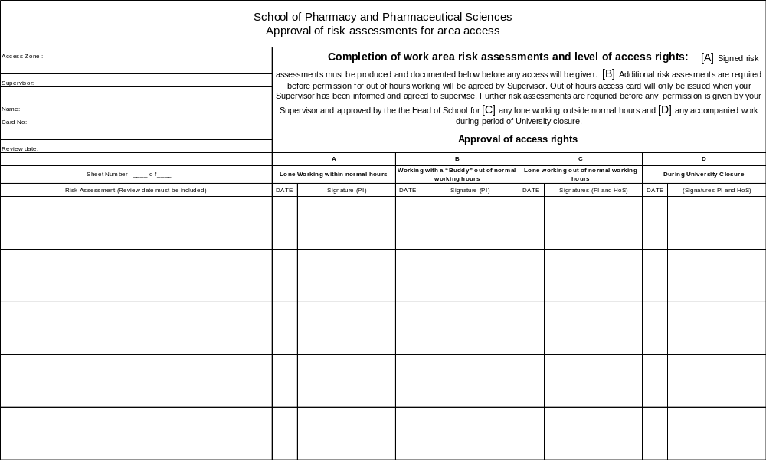
Bryce Modelling Lab, Stopford 2.181
Risk Assessment for Bryce Modelling Lab, Stopford 2.181 (review 27/6/13)
Dr Richard Bryce

